CLASS TEST -4

SET-2

1.Create a base class called Shape with virtual functions area() and perimeter(). Derive two

classes Rectangle and Triangle from the base class. Implement the area() and perimeter()

functions for each class.

OUTPUT:

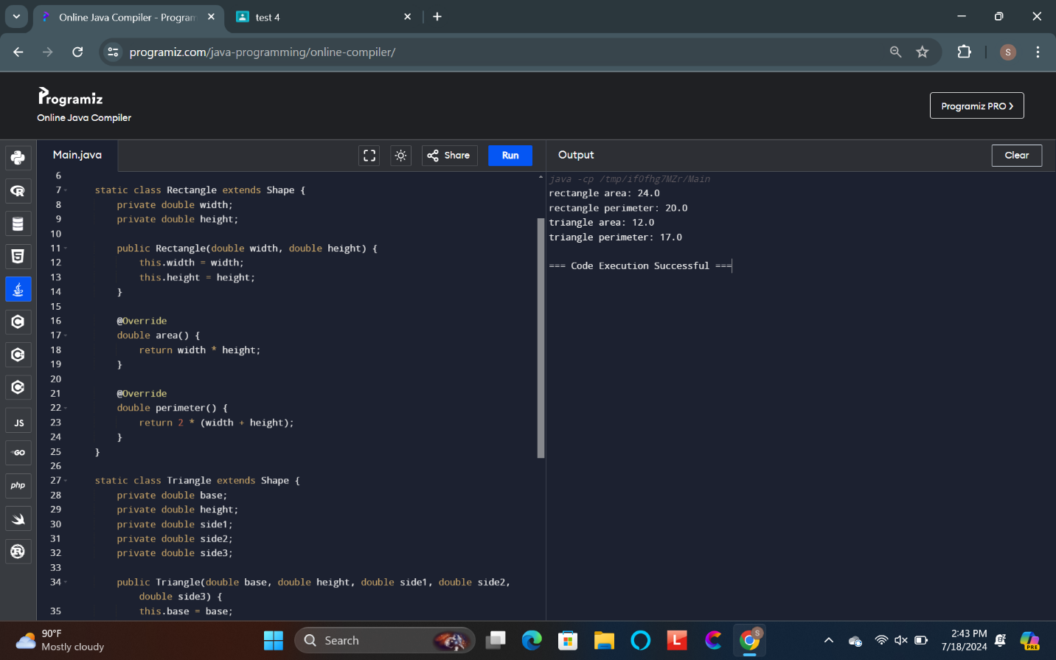

2. Create a base class called Animal with a virtual function move(). Derive two classes Bird and

Fish from the base class. Implement the move() function for each class.

OUTPUT:

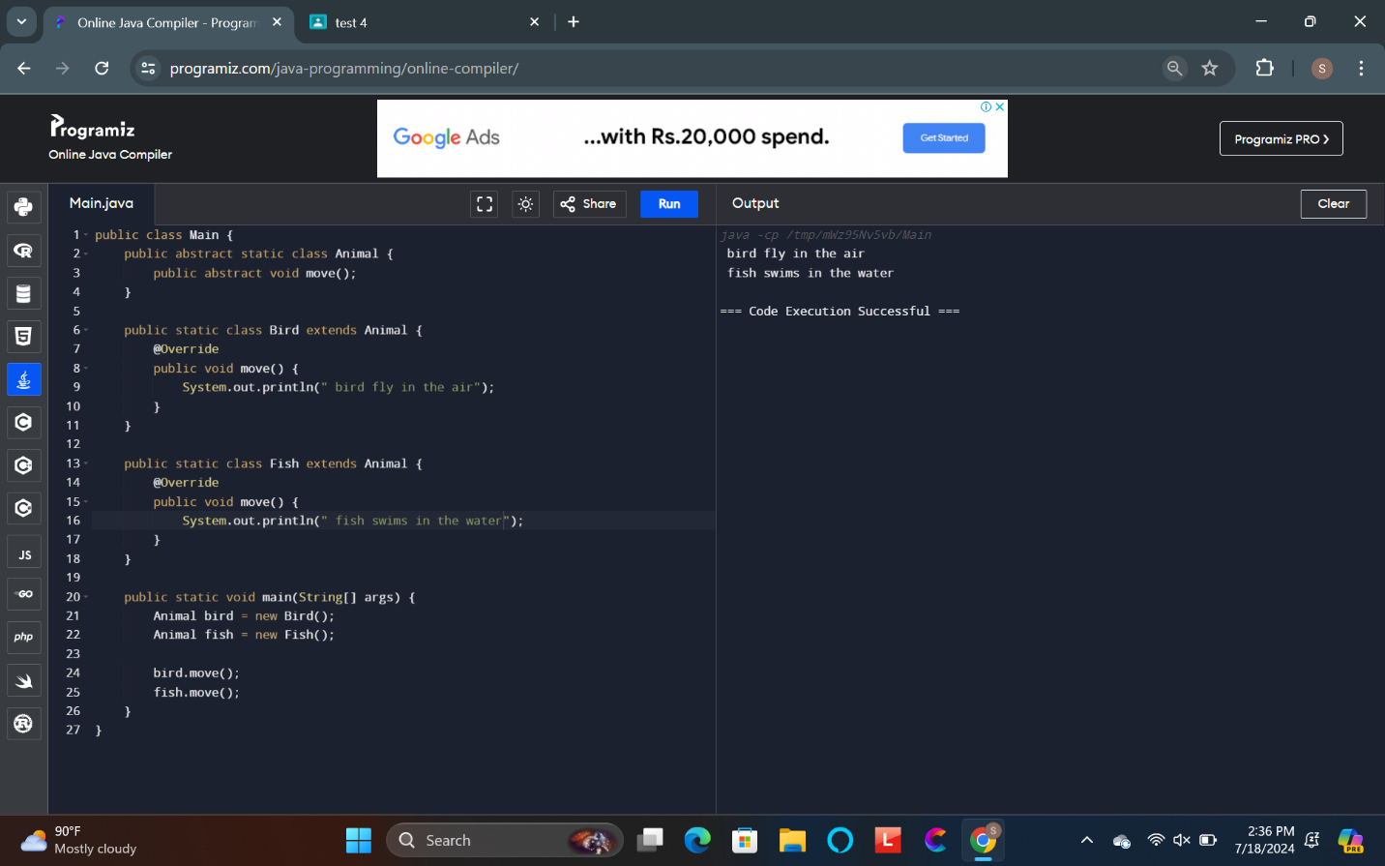

3. Create a base class called Person with a virtual function greet(). Derive two classes Student

and Teacher from the base class. Implement the greet() function for each class.

OUTPUT:

